**ELE222E INTRODUCTION TO ELECTRONICS (10730)**

**Midterm Exam #2** 🖉 **10 December 2013** ⌛ **13.30-15.30**

**İnci ÇİLESİZ, PhD**

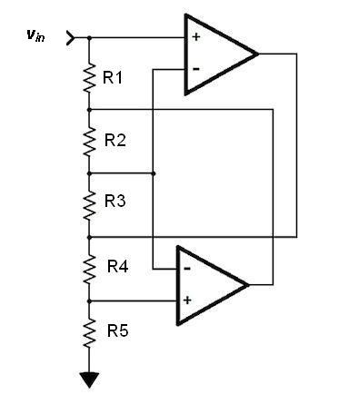

1. On the left you see an interesting OPAMP circuit. You will analyze this circuit and find the input resistance. Remember properties of an ideal OPAMP.
   * 1. Calculate voltages along the resistors in series. Realize which are predetermined by the wiring of OPAMP inputs. (10)
     2. Then calculate currents through each resistor, and finally (10)
     3. Find the input resistance of the whole circuit. (5)
2. On the right is another interesting circuit. Study the wiring and find the overall voltage gain. (20)



1. Look at the differential pair on the left. Find the gain and the differential input resistance when extra emitter resistors RE are inserted. (25)

You may have to use small signal circuit to analyze this problem.

1. 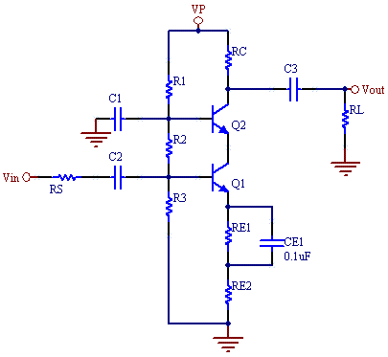Your last problem involves a cascade circuit.
   1. Have a close look at the circuit and see which resistors are going to have no effect on AC behavior of this circuit.
   2. For R1 = 20k, R2 = 4k7, R3 = 7k9, RC = 2k, RL = 50 Ω, RS = 5k, RE1 = 1k, RE2 = 100 Ω, hfe = hFE = 100,  
      hoe = hre = 0, VP = 9 V, VBE = 0,6 V, VT = 25 mV find the gain, input and output resistances of the circuit assuming all capacitors are ideal. For DC analysis you may neglect base currents. (30)

**SOLUTIONS:**

1. This circuit allows you to transfer a resistance, such as a load or a sensor output, to a higher or more convenient value.
   1. All OPAMP inputs see $v_{i}$, the voltage at the input terminal. Also the node between R2 and R3 sees $v_{i}$. (See )
   2. A current of $v_{i}/R_{5}$ flows through the bottom resistance, R5. That same current has to also flow through R4, so now we know the voltage on the node between R3 and R4: $v_{34}=v_{i}+R_{4}\left(\frac{v_{i}}{R_{5}}\right)$ = $v_{i}\left(1+\frac{R_{4}}{R_{5}}\right)$. If this is so, the current flowing through R3 and thus R2 is .

***v12***

Thus we know the voltage on the node between R1 and R2: $v_{12}=v_{i}+R_{2}\left(\frac{v_{i}-v_{34}}{R_{3}}\right)$ = $v_{i}+R_{2}\left(\frac{v_{i}-v_{i}\left(1+\frac{R_{4}}{R_{5}}\right)}{R_{3}}\right)$ = ${ v}_{i}\left(1-\frac{R_{2}R_{4}}{R_{3}R_{5}}\right)$. From here we can calculate the input current that also flows through R1 as .

***v34***

Also see <http://www.edn.com/electronics-blogs/analog-ic-startup/4395827/Clever-op-amp-circuits--but-are-they-practical->

1. This one is not as complex as it may look. First, there is no current flow through $R_{1}$. Thus the voltage at the inverting input of the OPAMP is $v_{1}$. A current of $v_{1}/R_{g}$ flows through the resistance $R_{g}$. Realize that the ground connection could have been another input! The current through $R_{2} is \frac{v_{1}-v_{2}}{R_{2}}$. Thus the current through the feedback loop is the sum of these two and subsequently ${ v}_{o}=v_{1}+R_{f}\left(\frac{v_{1}}{R_{g}}+\frac{v_{1}-v_{2}}{R_{2}}\right)=\left(1+\frac{R_{f}}{R_{g}}+\frac{R_{f}}{R_{2}}\right)v_{1}-\frac{R_{f}}{R_{2}}v_{2}$.

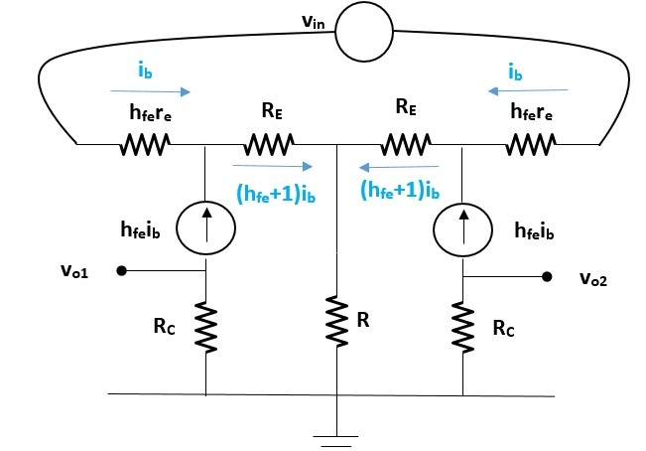

1. When you draw the small signal circuit, you see $v_{o1/2}= -R_{C}h_{fe}i_{b1/2}$ and

$v_{i1}=h_{fe}r_{e1}+{R_{E}(h}_{fe}+1)i_{b1}+{R(h}_{fe}+1)(i_{b1}+i_{b2})$

$v_{i2}=h_{fe}r_{e2}+{R_{E}(h}_{fe}+1)i_{b2}+{R(h}_{fe}+1)(i_{b1}+i_{b2})$

Thus $v_{in}=v_{1}-v_{2}$ has

$h_{fe}r_{e}+{R_{E}(h}_{fe}+1)≅h_{fe}r_{e}+h_{fe}R_{E}$

instead of just $h_{fe}r_{e}$. That means $\frac{v_{o1/2}}{v_{in}}=∓\frac{R_{C}}{r_{e}+R_{E}}$ and thus $r_{i}={2(h}_{fe}r_{e}+h_{fe}R_{E})$

Also have a look at

<http://paginas.fe.up.pt/~fff/eBook/MDA/Solu_ex_01.html> and <http://users.ece.gatech.edu/mleach/ece3050/homework/set09new.pdf>



1. 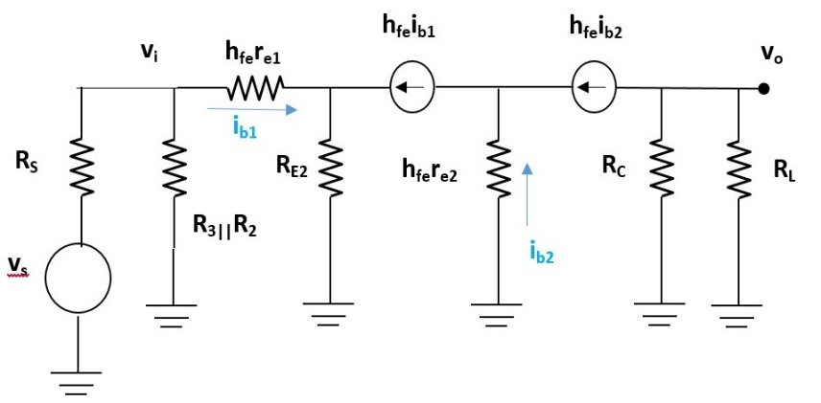Realize that R1 will have no effect on AC behavior as it is going to be grounded on both ends. The small signal circuit is then (in the graphs ***vin = vs***):

**ri**

since $v_{o}= -h_{fe}i_{b2}(R_{C}||R_{L}$)

and $v_{i}= i_{b1}h_{fe}r_{e1}+i_{b1}(h_{fe}+1)R_{E2}$ with $h_{fe}i_{b1}={(h}_{fe}+1)i_{b2}$,

assuming $h_{fe}i_{b1}≅h_{fe}i_{b2}$, and $h_{fe}+1≅h_{fe}$ i.e., $i_{b1}=i_{b2}$, $\frac{v_{o}}{v_{i}}= \frac{-(R_{C}||R_{L}) }{r_{e1}+R_{E2} }$

Now we need to do the DC analysis to complete calculations.

$$V_{B1}=\frac{{ R}_{3}}{R_{1}+R_{2}+R_{3}}V_{P}=2,18 V; V_{B2}=\frac{R_{2}+R_{3}}{R_{1}+R_{2}+R_{3}}V_{P}=3,48 V; V_{E1}=V_{B1}-V_{BE}=1,58 V$$

$I_{E1}= I_{C1}=I_{C2}= \frac{V_{E1}}{R_{E1}+R_{E2}}=1,44 mA$, $r_{e1}$ = $r_{e1}= \frac{25 mV}{1,44 mA}=17,4 Ω$ Thus $\frac{v_{o}}{v_{i}}= \frac{-(R_{C}||R_{L}) }{r_{e1}+R_{E2} }= -12,17$

Obviously $r_{o}=R_{C}=2k$, $r_{i}=\frac{v_{i}}{i_{b1}}=h_{fe}r_{e1}+\left(h_{fe}+1\right)R_{E2}≅h_{fe}\left(r_{e1}+R_{E2}\right)=11k74$

$\frac{R_{2}||R_{3}||r_{i}}{R_{2}||R_{3}||r_{i}+R_{S}}=0,979 → \frac{v_{o}}{v_{s}}=\frac{v_{o}}{v_{i}} \frac{R_{2}||R_{3}||r_{i}}{R_{2}||R_{3}||r_{i}+R_{S}}= -11,9$

Also check <http://www.daycounter.com/Calculators/Cascode/BJT-Cascode-Calculator.phtml>